**Machine learning used to solve:**

**Telecon Customer Churn Prediction**



1)Description

The task of this project is to build predictive models that can accurately predict whether a Telecon customer will churn or not based on historical customer data.

Customer churn is a critical issue for telecommunication companies. Losing customers to churn can lead to significant revenue loss and impact the company's growth. Therefore, it is essential to predict potential churners accurately and take proactive measures to retain them. In this project I can work with historical customer data, and my goal is to develop machine learning models that can predict customer churn effectively.

The dataset consists of various customer attributes, such as customer demographics, subscription details, service usage, and billing information. The target variable is the "Churn" column, which indicates whether the customer churned (1) or not (0).

**Evaluation**

Model is been evaluated based on the Area Under Curve (AUC). The AUC is a commonly used metric to evaluate the performance of binary classification models, and it measures the trade-off between the true positive rate (sensitivity) and the false positive rate (1-specificity).

The AUC was the metric for which the models were trained, hence the metric to optimize. For each model, I present the results in terms of both AUC and accuracy

The main objective was to beat the benchmark of an online competition, held on kaggle, in which the threshold was set at 0.73 AUC on test data.

2)Results & Analysis

First of all, in the preprocessing phase, I tried to understand which features could be most separable with the output column (churn), obtaining that the most linearly separable property with the output was tenure, as shown below and in the script.

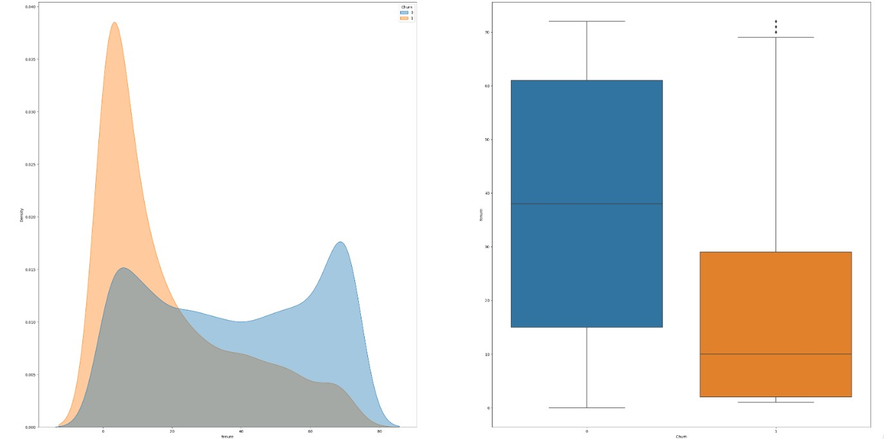

Training phase:

I tried various types of models.

The first was the Random Forest Classifier.

Initially the parameters used were:

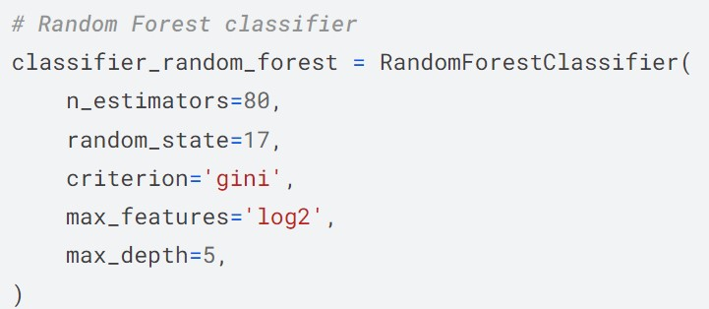

With these results:

Training Accuracy: 0.80877504438245

Test Accuracy: 0.7983441750443524

Training AUC: 0.6997434110700077

Test AUC: 0.6979345022648952

After a long search for parameter remodeling, both manual and automated, I found that the best performance in terms of ROC-AUC for the test data was obtained from the following model:

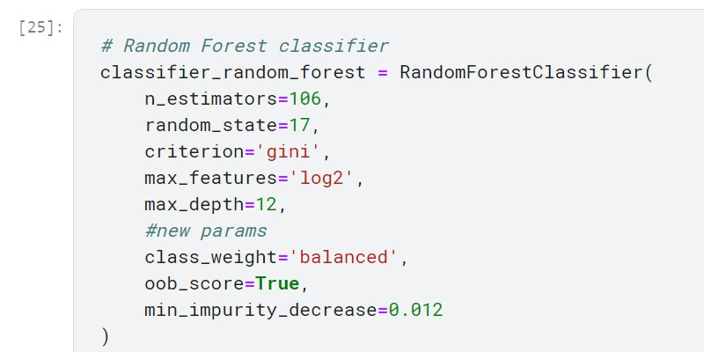

That leds to the following result:

Training Accuracy: 0.7364950545270099

Test Accuracy: 0.7279716144293318

Training AUC: 0.7625228163127259

Test AUC: 0.7626203789996894

Graph that shows the difference between the 2 setups:

It is clearly visible that the first setup has better performance in terms of accuracy, while the second maximizes the ROC curve.

Both of the setups shows little gaps between performace on test and training datasets, highlighting signs of possible underfitting.

The second classifier used was the Decision Tree Classifier, with the following parameters:

max_depth=7, min_samples_split=3, min_samples_leaf=3, max_features='log2'

And it led to these results:

Training Accuracy: 0.8113111843773776

Test Accuracy: 0.7717327025428741

Training AUC: 0.7405395375279816

Test AUC: 0.7110732424485433

I then moved on to the K-Nearest Neighbors classifier and maximum result I had with this classifier was:

Training Accuracy: 0.8021810803956378

Test Accuracy: 0.7882909520993495

Training AUC: 0.73431547113794

Test AUC: 0.7324524805479096

Then, I Tried with the Perceptron Classifier, but from the beginning the results left no room for optimizations via parameter tuning.

These are the strating results:

Training Accuracy: 0.7476540705046919

Test Accuracy: 0.7321111768184506

Training AUC: 0.6535340445048053

Test AUC: 0.6385234472644256

With an initial AUC-ROC score of less than 0.64, there was no point in trying to optimize this model.

Then I tried the Logistic Regression Classifier, with different versions of parameters, and this is the result I have obtained:  
Training Accuracy: 0.8105503423788993

Test Accuracy: 0.7953873447664104

Training AUC: 0.7269984589530092

Test AUC: 0.7198600966644271

In the end, as the last model I tried gradient boosting classifier.

This gave me the best results in terms of AUC on test data together with the random forest classifier.

The initial results of the model were:

Training Accuracy: 0.8110726203348112

Test Accuracy: 0.77123211272283

Training AUC: 0.71112821998567

Test AUC: 0.7182213338294

After manually tuning the parameters, I got the best performance

with the following setup:

n_estimators=77,

learning_rate=0.1,

max_depth=3,

min_samples_split=2,

min_samples_leaf=1,

subsample=1,

max_features=None,

loss='log_loss',

criterion='friedman_mse',

warm_start=False,

validation_fraction=0.95,

n_iter_no_change=None

That gaves me this outcome:

Training Accuracy: 0.8300786203398428

Test Accuracy: 0.8013010053222945

Training AUC: 0.7506078318350567

Test AUC: 0.7311213579256884

Below is the graph comparing all the models on the AUC curve for

the test dataset:

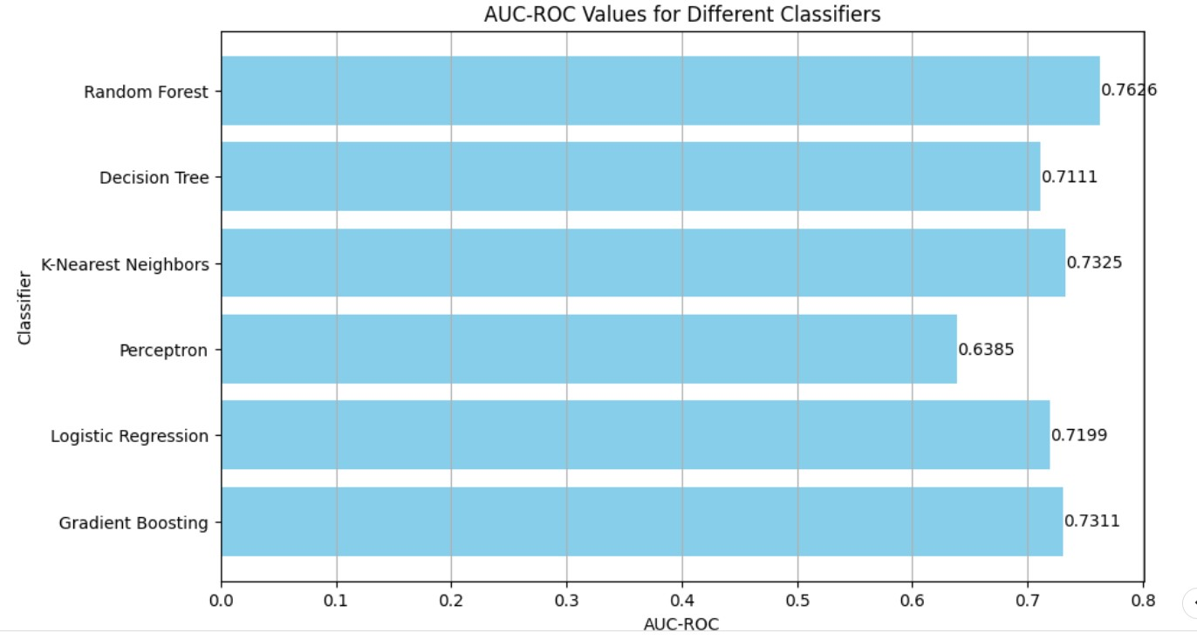

After obtaining these results, I chose to proceed with a grid search on two specific models: The RandomForestClassifier and the GradientBoostDescent.

The random forest because it had the most important result in terms of AUC, while the Gradient Boost Classifier because it was the most sensitive to parameter changes.

The results obtained with the grid search applied to the random forest classifier are the following:

Best Parameters:

{'criterion': 'entropy',

'max_depth': 12,

'min_impurity_decrease': 0.012,

'n_estimators': 91}

Test Accuracy: 0.7936132465996452

Test AUC-ROC: 0.8282716357094866

And the results obtained with the grid search applied to the gradient boosting classifier are the following:

Best Parameters:{'learning_rate': 0.1,'max_depth': 3,'n_estimators': 76}

Test Accuracy: 0.8018923713778829

Test AUC-ROC: 0.8412415021276288

Graph showing the two classifiers obtained with grid search:

And to compare them again with all the models tested:

This shows a great upgrade, and the models obtained with grid search far exceed the threshold set in this project.

3)Flow Chart

First of all, for the creation of the flowchart, a general scheme can be created which brings together all the possible creations and implementations of the models tested in this project.

The models all follow a sequential construction and make use of very renowned libraries in the ML field.

However, it is possible to reconstruct the sequentiality of both the normal classifier and the grid search steps applied on the classifier.

The following represents the construction and execution of a general classifier:

**Choose the classifier**, for instance here is the Perceptron. There is also the **selection of the initial hyperparameters** (in this case max_iter and radom_state.

#Perceptron Classifier

classifier_perceptron = Perceptron(max_iter=1000, random_state=42)

classifier_perceptron.fit(X_train_scaled, Y_train)

**Training of the model on the different datasets**:

Y_pred_train = classifier_perceptron.predict(X_train_scaled)

Y_pred_test = classifier_perceptron.predict(X_test_scaled)

Pred_Perceptron = classifier_perceptron.predict(X_final_test_scaled)

**Evaluation of the model, following the metrics chosen** (with the **printing phase** included):

train_accuracy = accuracy_score(Y_train, Y_pred_train)

print("Training Accuracy:", train_accuracy)

test_accuracy = accuracy_score(Y_test, Y_pred_test)

print("Test Accuracy:", test_accuracy)

# Calculate AUC for the training set

train_auc = roc_auc_score(Y_train, Y_pred_train)

print("Training AUC:", train_auc)

# Calculate AUC for the test set

test_auc = roc_auc_score(Y_test, Y_pred_test)

print("Test AUC:", test_auc)

By applying grid search the scheme can be slightly modified as follows:

Definitions of parameters to explore:

gb_hyperParams = {

    'n_estimators': range(74, 82),

    'learning_rate': [ 0.09, 0.1, 0.11, 0.12],

    'max_depth': range(3, 6)

}

Create Gradient Boosting Classifier, the base classifier

gb_classifier = GradientBoostingClassifier(

    loss='log_loss',           # 'deviance' is used for binary classification

    criterion='friedman_mse',  # Quality of split function

    subsample=1,               # Use all samples for fitting individual trees

    max_features=None,         # Number of features to consider when looking for the best split

    min_samples_split=2,       # Minimum number of samples required to split an internal node

    min_samples_leaf=1,        # Minimum number of samples required to be at a leaf node

    warm_start=False,          # Whether to reuse solution of the previous call to fit and add more estimators

    validation_fraction=0.95,  # Fraction of training data to set aside as validation set for early stopping

    n_iter_no_change=None     # Number of iterations with no improvement before stopping fitting

)

Create Grid Search istance

grid_search = GridSearchCV(estimator=gb_classifier, param_grid=gb_hyperParams, cv=5, scoring='roc_auc')

Fit the grid search to the data

grid_search.fit(X_train_scaled, Y_train)

Print the best parameters found

print("Best Parameters:", grid_search.best_params_)

Get the best estimator

best_classifier = grid_search.best_estimator_

Get the accuracy and print it

test_accuracy = best_classifier.score(X_test_scaled, Y_test)

print("Test Accuracy:", test_accuracy)

Evaluate the best estimator, calculate and print the ROC-AUC

Y_pred_proba = best_classifier.predict_proba(X_test_scaled)

test_auc_roc = roc_auc_score(Y_test, Y_pred_proba[:, 1])

print("Test AUC-ROC:", test_auc_roc)

4)Code

Below I leave the link to the driver containing the notebook file, in which the data preprocessing part is also visible.

https://drive.google.com/file/d/18gFXnVbWtg30Jdd_dfqKV8TubD6RGIjh/view?usp=drive_link